**Model Development Phase Template**

|  |  |
| --- | --- |
| Date | 24 April 2024 |
| Team ID | team-739906 |
| Project Title | Identifying Airline Passenger Satisfaction Using Machine Learning |
| Maximum Marks | 4 Marks |

**Initial Model Training Code, Model Validation and Evaluation Report**

The initial model training code will be showcased in the future through a screenshot. The model validation and evaluation report will include classification reports, accuracy, and confusion matrices for multiple models, presented through respective screenshots.

**Initial Model Training Code:**

**Decision Tree:**

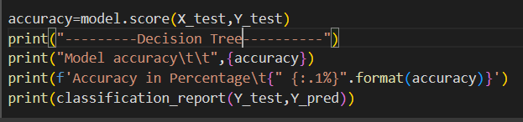

**Logistic Regression:**

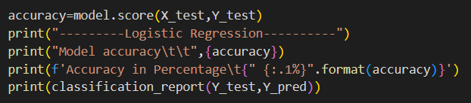

**Random Forest:**

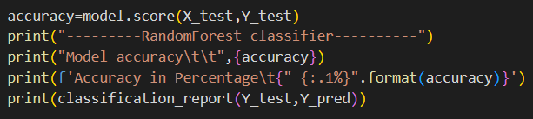

**K Nearest Nighbor:**

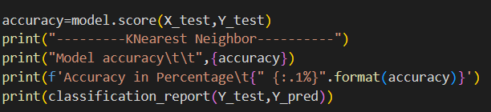

**Model Validation and Evaluation Report:**

|  |  |  |  |  |
| --- | --- | --- | --- | --- |
| **Model** | **Classification Report** | | **Accuracy** | **Confusion Matrix** |
| Decision Tree |  | | 91.4% |  |
| Logistic Regression |  | | 83.9% |  |
| Random Forest |  | | 94.5% |  |
| K Nearest Neighbor |  | | 89.3% |  |
|  | |
|  | |